Terraform Modules:
=================
Modules is a collection of configuration files in a directory.

For example if we want to create two ec2 for different environemnts
then i can create a directory for aws-instance configuration.
Example:
=======
resource "aws+instance" "webserver"
ami = "var.ami"
instance_type = "t2.micro"
}

now let me create a directory for dev under root directory.

example:
module "dev-webserver" {
source = "../aws_instance"
ami = "ami-02f3f602d23f1659d"
}

Terraform workspaces:
====================
Workspace can be used if we have multiple project/environments using the same configuration.

Workspace commands:
==================
terraform workspace new projectA --> to create a workspace names projectA
terraform workspace list --> to list the workspaces available
terraform workspace select projectA --> to swtich to specific workspace

Example:
main.tf:
=======
resource "aws+instance" "webserver"
ami = "var.ami"
instance_type = "t2.micro"
}
variable.tf:
===========
variable "ami" {
type = map
default = {
"ProjectA" = "ami-02f3f602d23f1659d"
"ProjectB" = "ami-02f3f602d23f1659d"
}
}

when using workspaces state files will be created in the main directory
under a forlder "terraform.tfstate.d"

- Provision EC2, S3, and VPC using Terraform modules.

Prerequisites (Once Only)

1. Install Terraform
2. Install AWS CLI
3. Configure AWS credentials:

```bash
aws configure
```

Recommended Project Structure

terraform-aws-instances/
│
├── modules/
│ ├── vpc/
│ │ ├── main.tf
│ │ ├── variables.tf
│ │ └── outputs.tf
│ │
│ ├── ec2/
│ │ ├── main.tf
│ │ ├── variables.tf
│ │ └── outputs.tf
│ │
│ └── s3/
│ ├── main.tf
│ ├── variables.tf
│ └── outputs.tf
│
├── main.tf
├── variables.tf
├── outputs.tf
└── terraform.tfvars

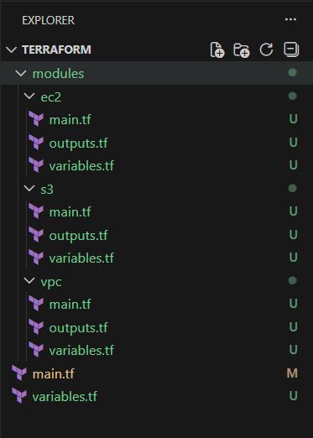

STEP 1: Create VPC Module

modules/vpc/main.tf

```hcl
resource "aws_vpc" "this" {
cidr_block = var.vpc_cidr
enable_dns_support = true
enable_dns_hostnames = true

tags = {
Name = var.vpc_name
}
}

resource "aws_subnet" "public" {
vpc_id = aws_vpc.this.id
cidr_block = var.public_subnet_cidr
availability_zone = var.az
map_public_ip_on_launch = true

tags = {
Name = "public-subnet"
}
}
```

modules/vpc/variables.tf

```hcl
variable "vpc_name" {}
variable "vpc_cidr" {}
variable "public_subnet_cidr" {}
variable "az" {}
```

modules/vpc/outputs.tf

```hcl
output "vpc_id" {
value = aws_vpc.this.id
}

output "subnet_id" {
value = aws_subnet.public.id
}
```
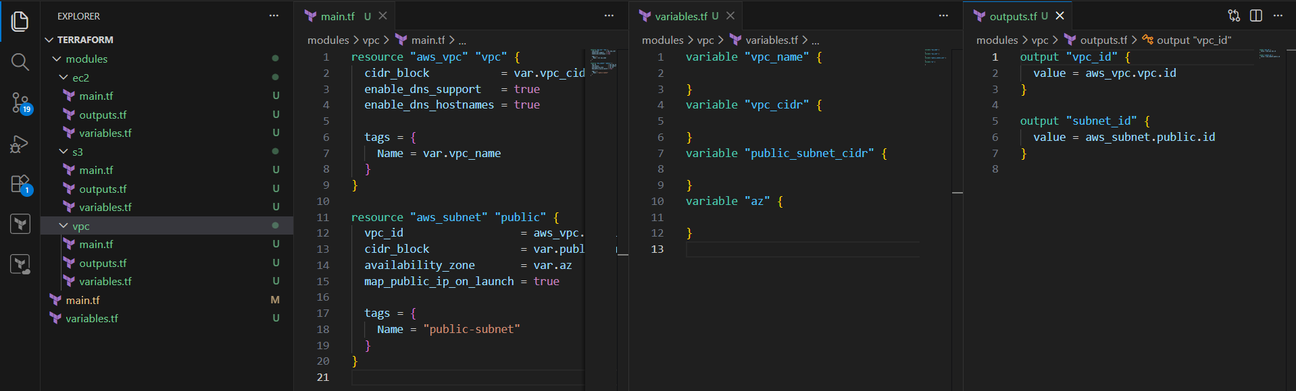

What this does

* Creates a VPC
* Creates a public subnet
* Exposes VPC ID & Subnet ID for other modules

STEP 2: Create EC2 Module

modules/ec2/main.tf

```hcl
resource "aws_instance" "this" {
ami = var.ami
instance_type = var.instance_type
subnet_id = var.subnet_id
key_name = var.key_name

user_data = <<-EOF
#!/bin/bash
yum install -y httpd
systemctl start httpd
systemctl enable httpd
EOF

tags = {
Name = var.instance_name
}
}
```

modules/ec2/variables.tf

```hcl
variable "ami" {}
variable "instance_type" {}
variable "subnet_id" {}
variable "key_name" {}
variable "instance_name" {}
```

modules/ec2/outputs.tf

```hcl
output "instance_id" {
value = aws_instance.this.id
}
```

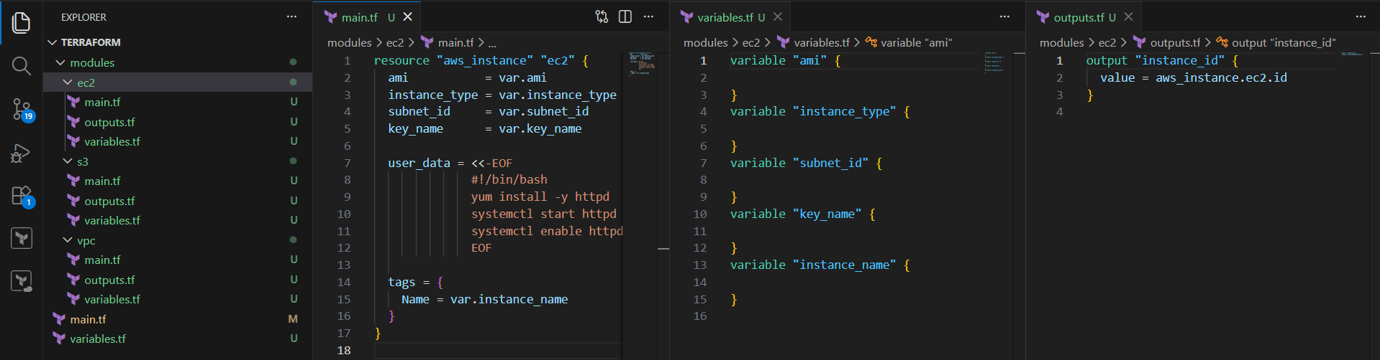

What this does

* Launches EC2
* Installs Apache (`httpd`)
* Uses subnet from VPC module

STEP 3: Create S3 Module

modules/s3/main.tf

```hcl
resource "aws_s3_bucket" "this" {
bucket = var.bucket_name

tags = {
Name = var.bucket_name
}
}
```

modules/s3/variables.tf

```hcl
variable "bucket_name" {}
```
modules/s3/outputs.tf

```hcl
output "bucket_name" {
value = aws_s3_bucket.this.bucket
}
```

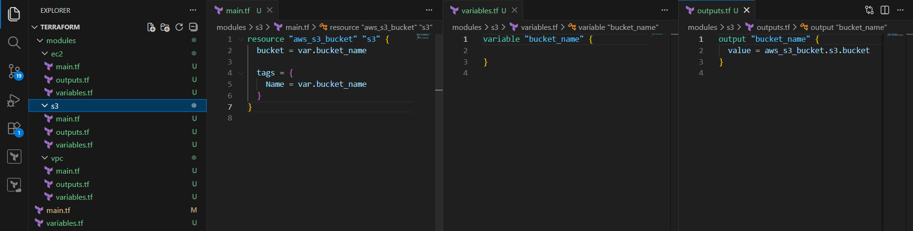

What this does

* Creates an S3 bucket
* Can be used later for backend or storage

STEP 4: Root Module (Connect Everything)

main.tf

```hcl
provider "aws" {
region = "us-east-1"
}

module "vpc" {
source = "./modules/vpc"
vpc_name = "demo-vpc"
vpc_cidr = "10.0.0.0/16"
public_subnet_cidr = "10.0.1.0/24"
az = "us-east-1a"
}

module "ec2" {
source = "./modules/ec2"
ami = "ami-0c1fe732b5494dc14"
instance_type = "t3.micro"
subnet_id = module.vpc.subnet_id
key_name = "my-key"
instance_name = "web-server"
}

module "s3" {
source = "./modules/s3"
bucket_name = "aniketh-terraform-bucket-123"
}
```

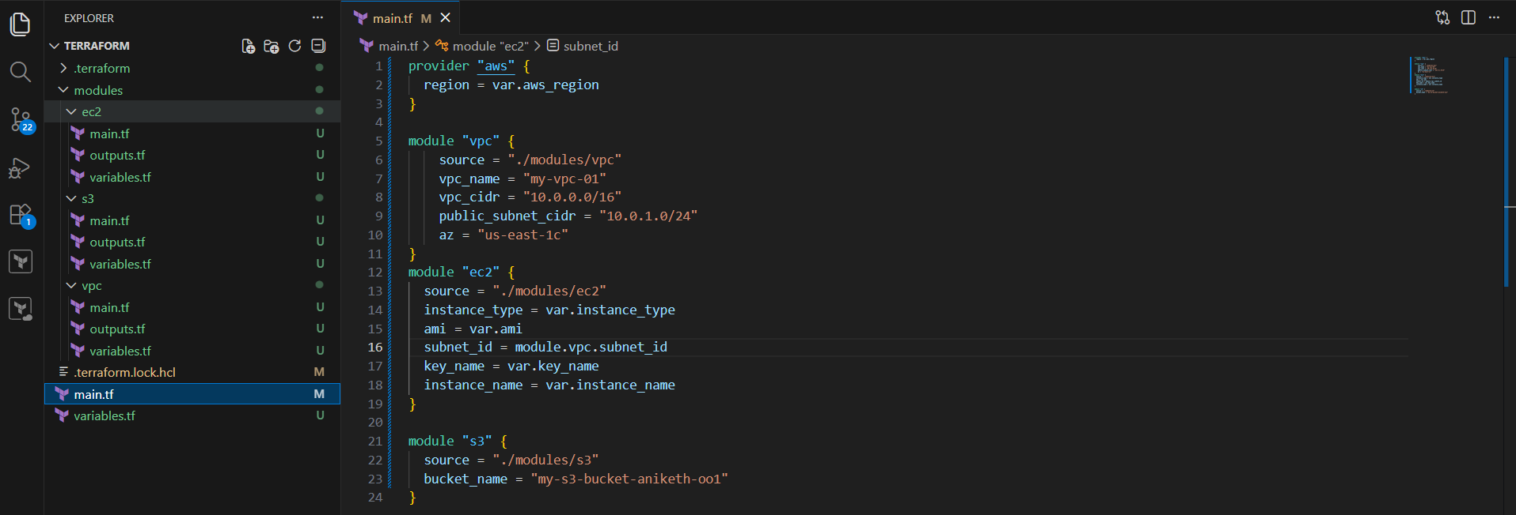

STEP 5: Terraform Commands (Execution Order)

```bash
terraform init
terraform validate
terraform plan
terraform apply
```

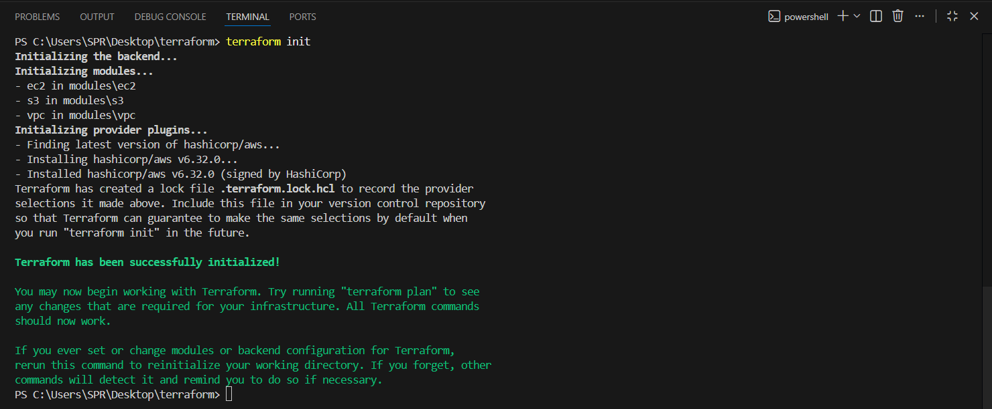

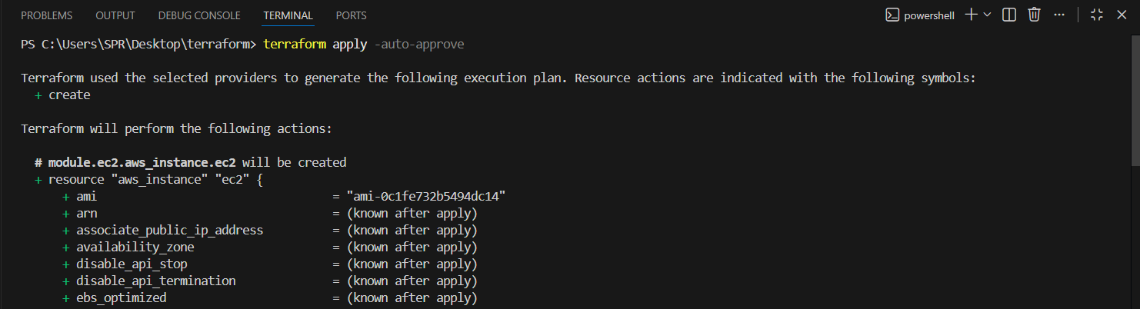
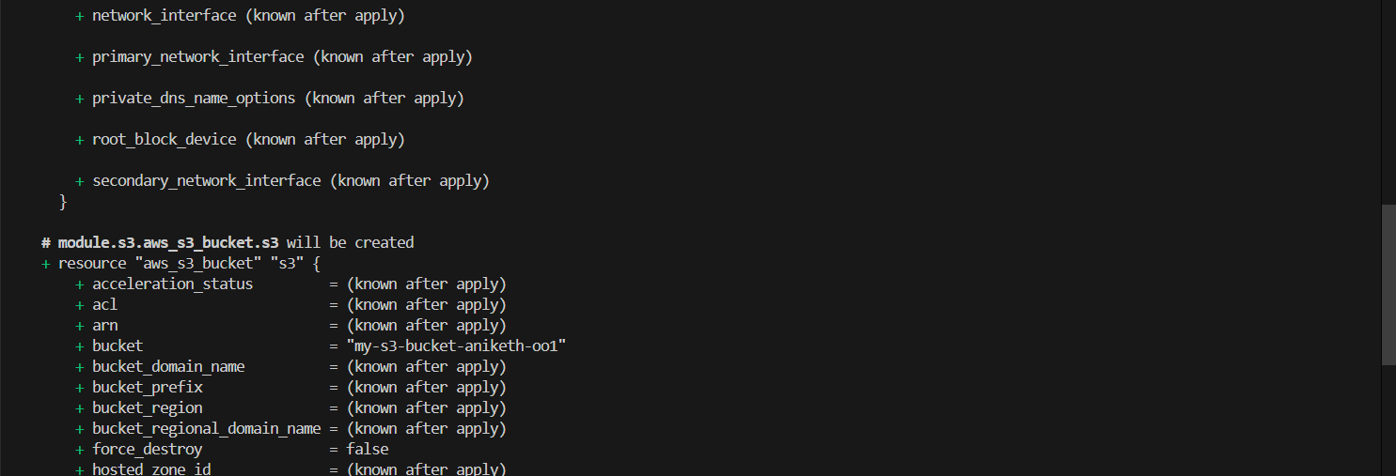
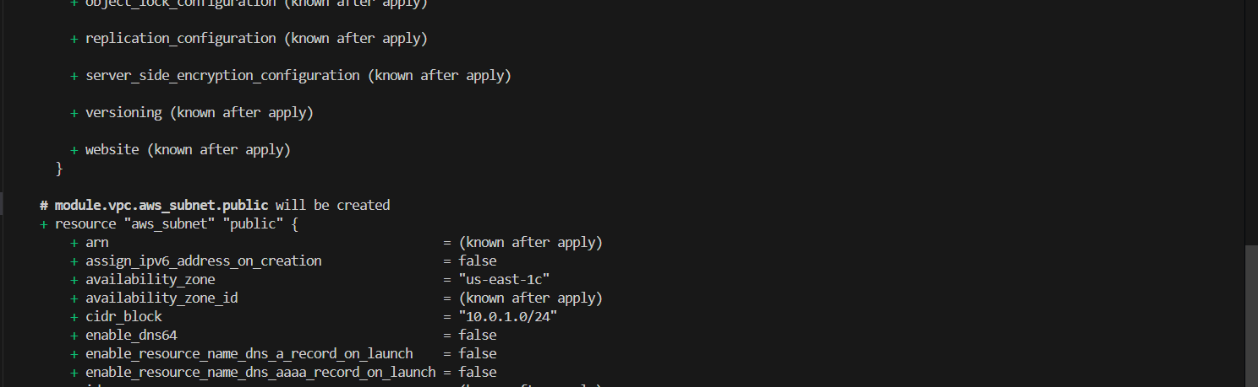
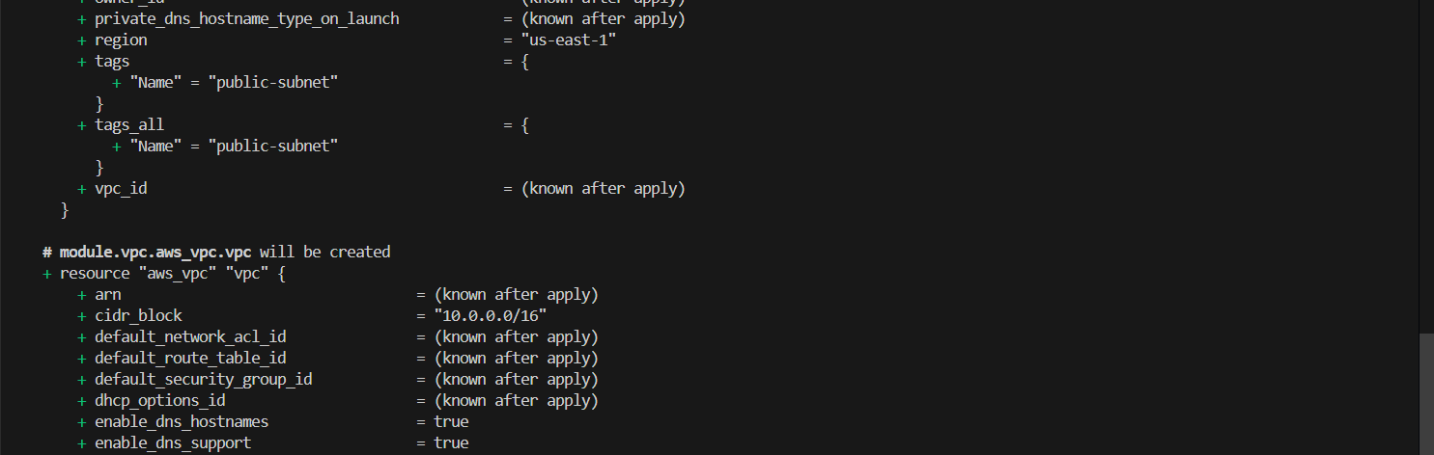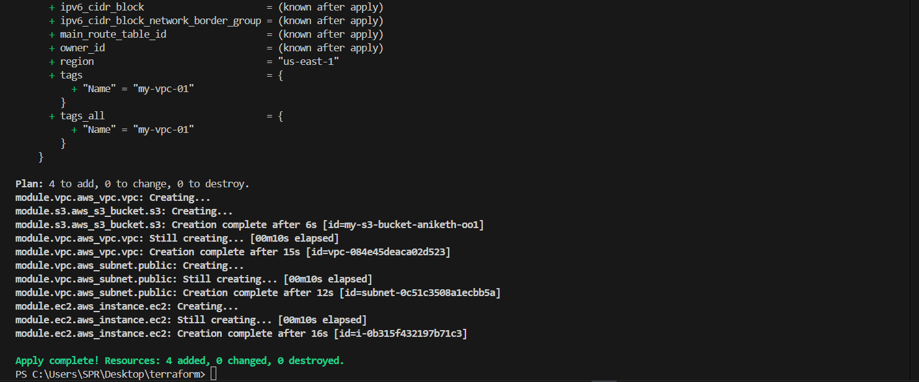

To destroy:

terraform destroy

Dependency Flow

VPC → Subnet → EC2
S3 → Independent

Terraform automatically knows:

* EC2 depends on VPC
* S3 is independent

Final Result

✔ VPC created
✔ Public Subnet created
✔ EC2 launched inside VPC
✔ Apache installed automatically
✔ S3 bucket created
✔ Clean reusable modules

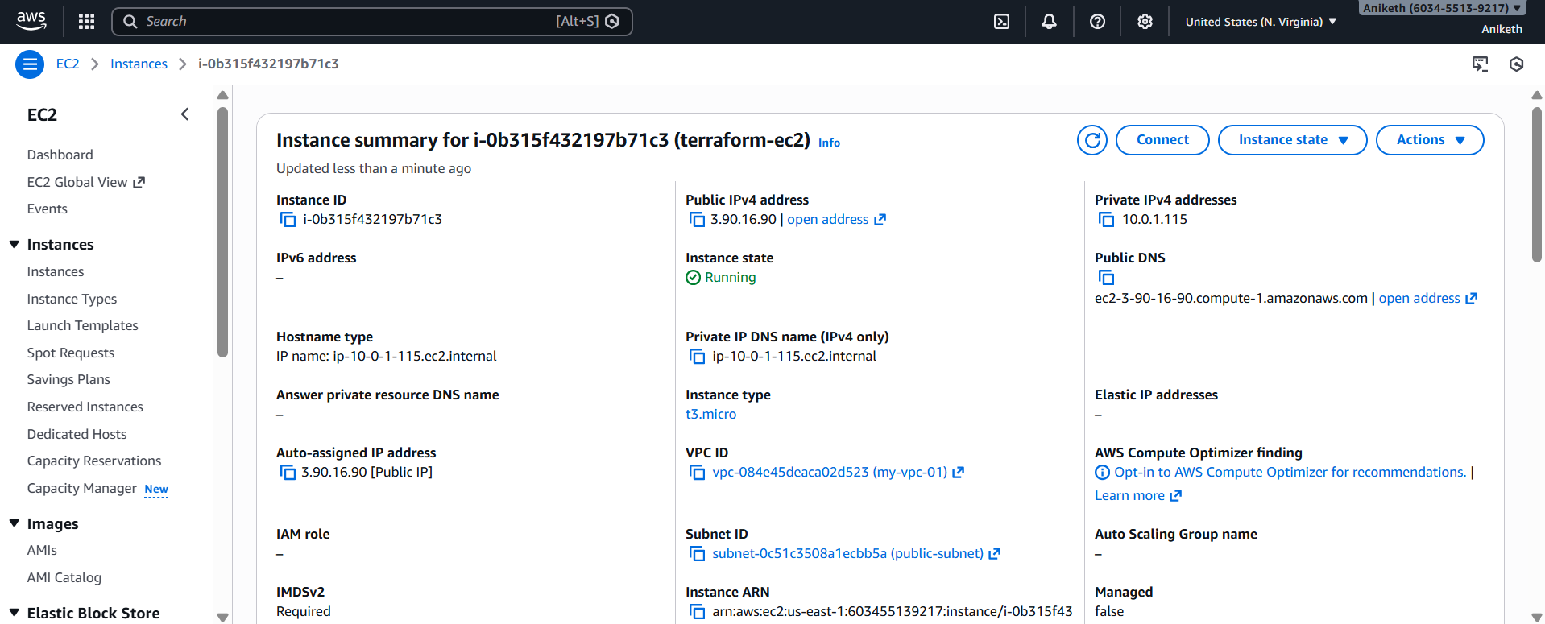

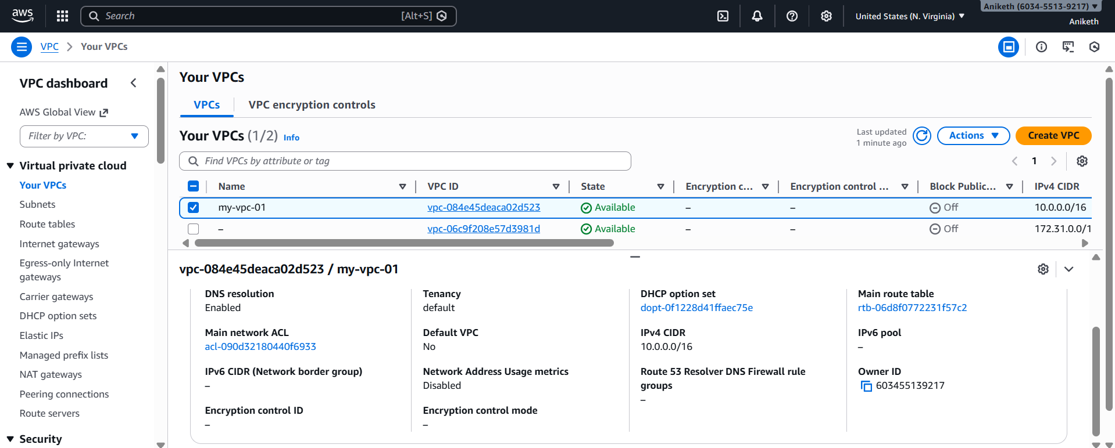

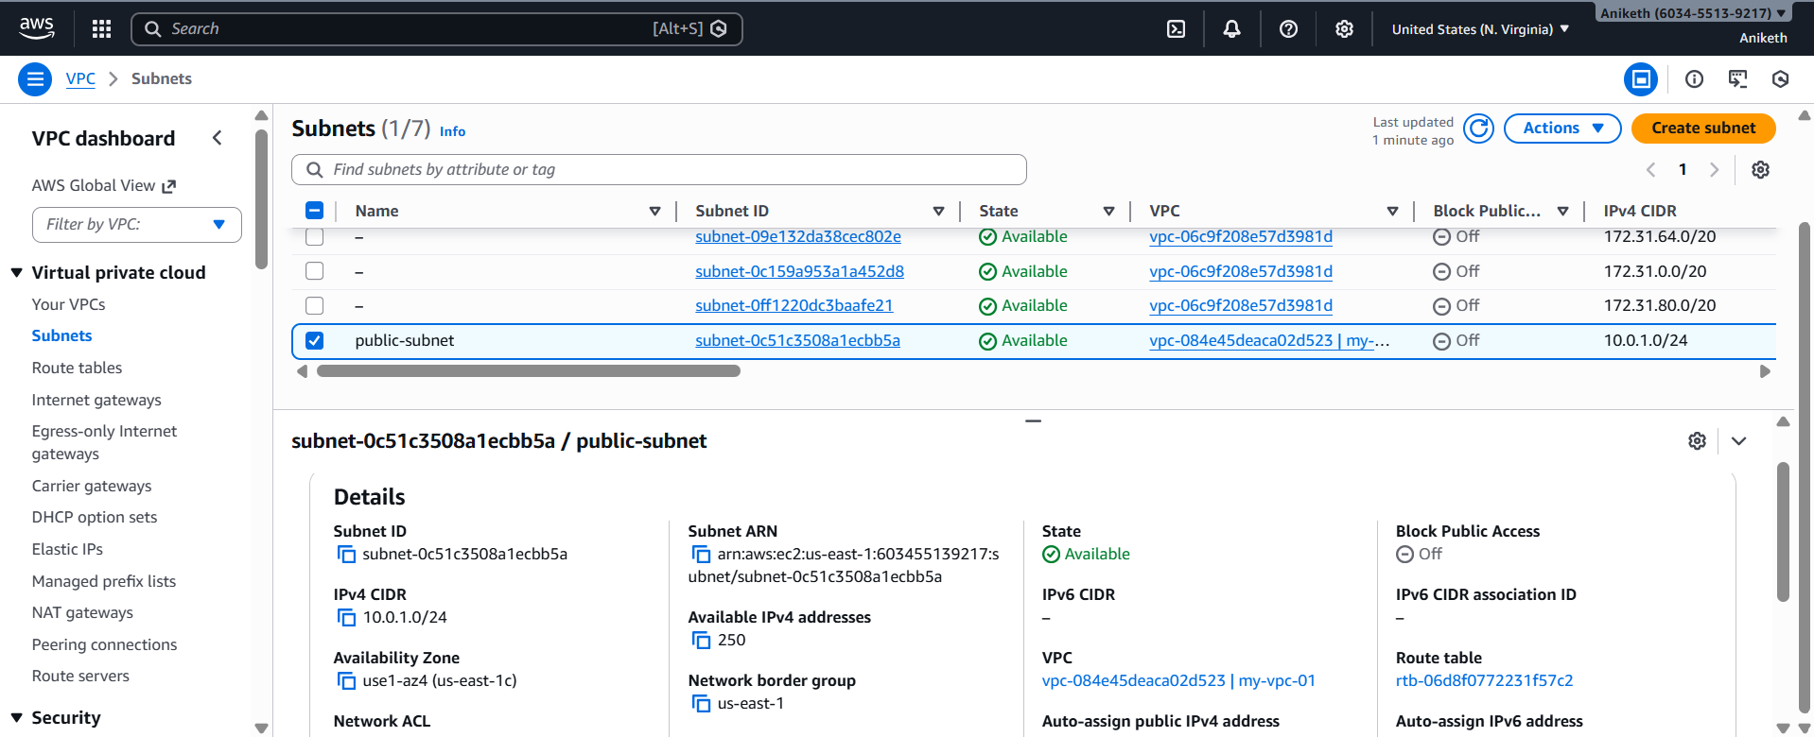

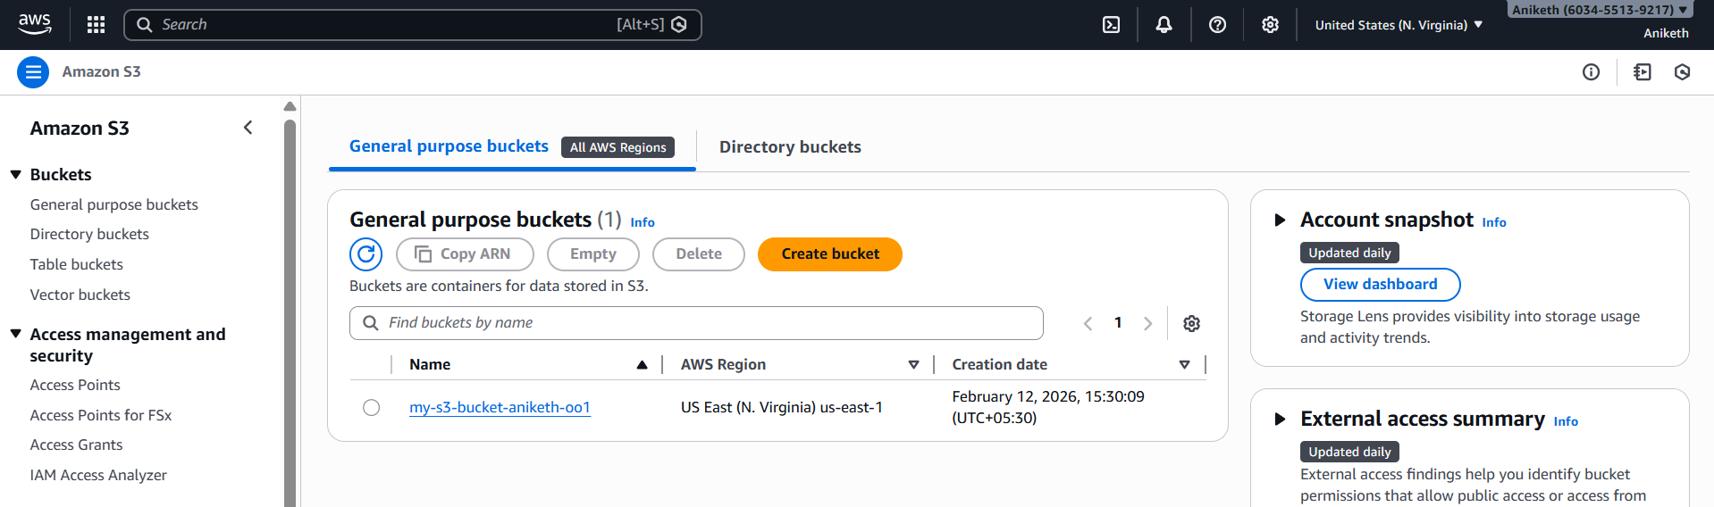

###################################################################################

- Provision EC2 for 3 different environments (Dev, Staging, and Prod) using Terraform workspaces.

Concept (How Workspaces Help)

* One Terraform codebase
* Multiple environments
* Terraform automatically switches values based on:

```hcl
terraform.workspace
```

| Workspace | EC2 Size | Environment Tag |
| --------- | --------- | --------------- |
| dev | t3.micro | Dev |
| staging | t3.small | Staging |
| prod | c7i-flex.large | Prod |

Project Structure

```text
terraform-ec2-workspaces/
├── main.tf
├── variables.tf
├── outputs.tf
```

main.tf

```hcl
terraform {
required_version = ">= 1.5.0"

required_providers {
aws = {
source = "hashicorp/aws"
version = "~> 5.0"
}
}
}

provider "aws" {
region = var.aws_region
}

locals {
instance_type_map = {
dev = "t3.micro"
staging = "t3.small"
prod = "c7i-flex.large"
}

env = terraform.workspace
}

resource "aws_instance" "ec2" {
ami = var.ami_id
instance_type = local.instance_type_map[local.env]
key_name = var.key_name

tags = {
Name = "ec2-${local.env}"
Environment = local.env
ManagedBy = "Terraform"
}
}
```

variables.tf

```hcl
variable "aws_region" {
description = "AWS region"
default = "us-east-1"
}

variable "ami_id" {
description = "AMI ID"
default = "ami-0c1fe732b5494dc14" # Amazon Linux 2 (us-east-1)
}

variable "key_name" {
description = "EC2 key pair name"
default = "logical"
}
```

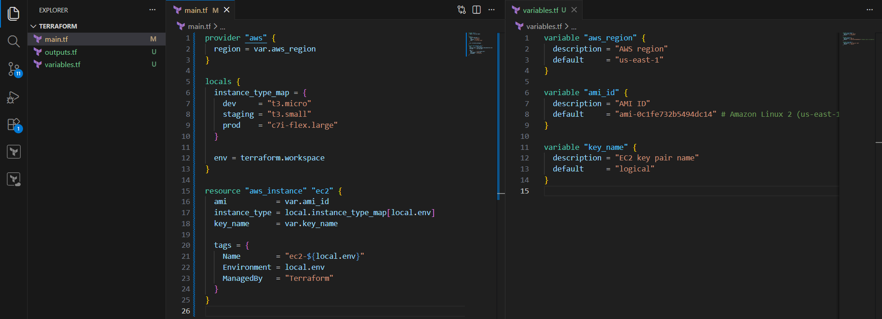

outputs.tf

```hcl
output "instance_id" {
value = aws_instance.ec2.id
}

output "public_ip" {
value = aws_instance.ec2.public_ip
}
```
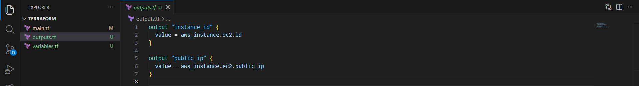

Save it.

Workspace Commands

Initialize Terraform

terraform init

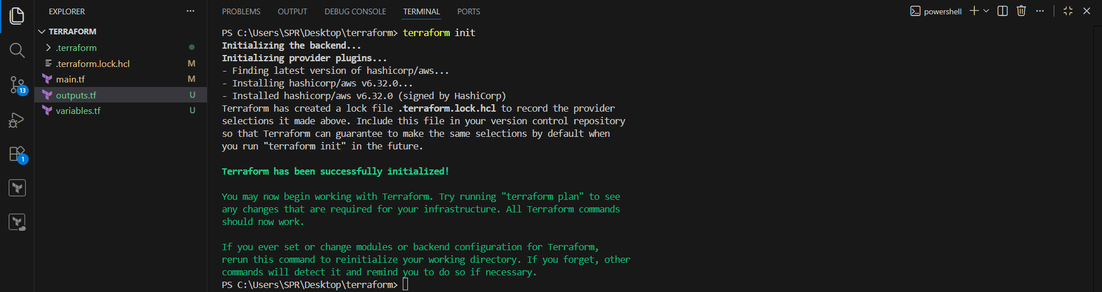

Create Workspaces

```bash
terraform workspace new dev
terraform workspace new staging
terraform workspace new prod
```
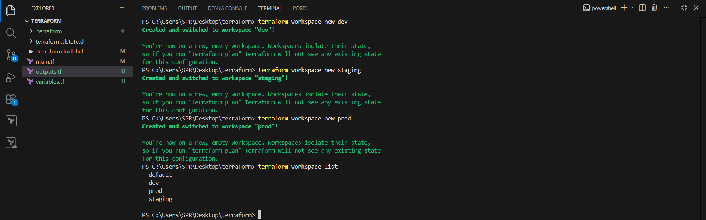

Deploy to DEV

```bash
terraform workspace select dev
terraform apply -auto-approve
```

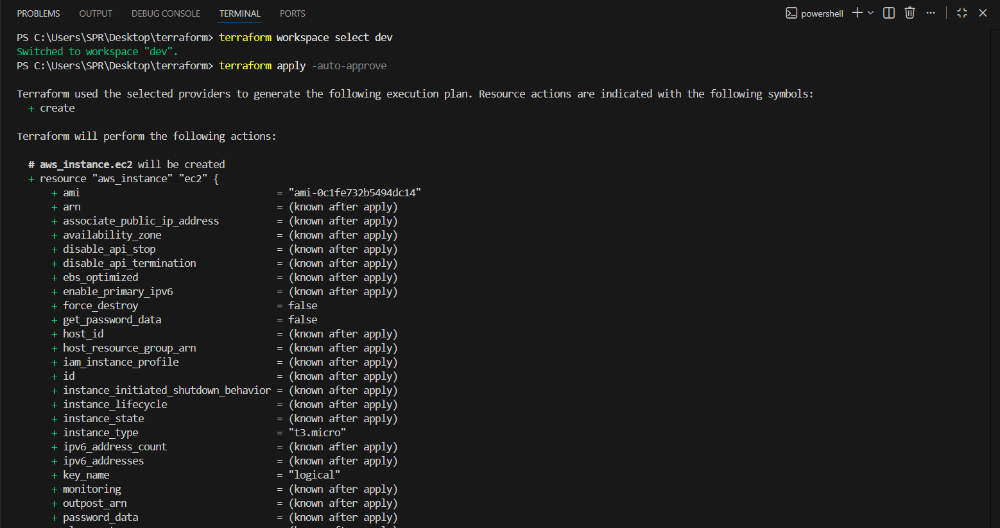
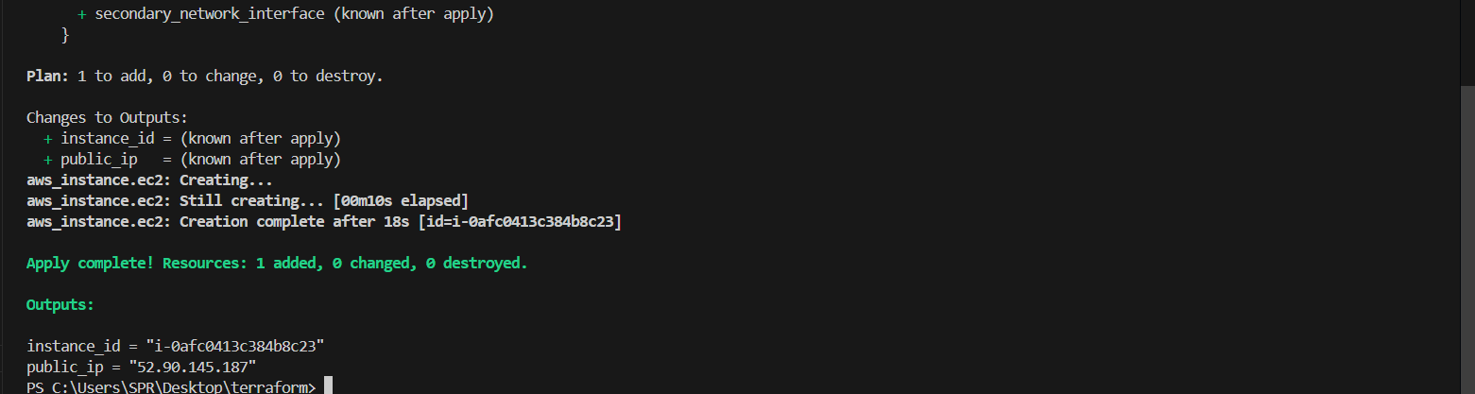

Deploy to STAGING

```bash
terraform workspace select staging
terraform apply -auto-approve
```

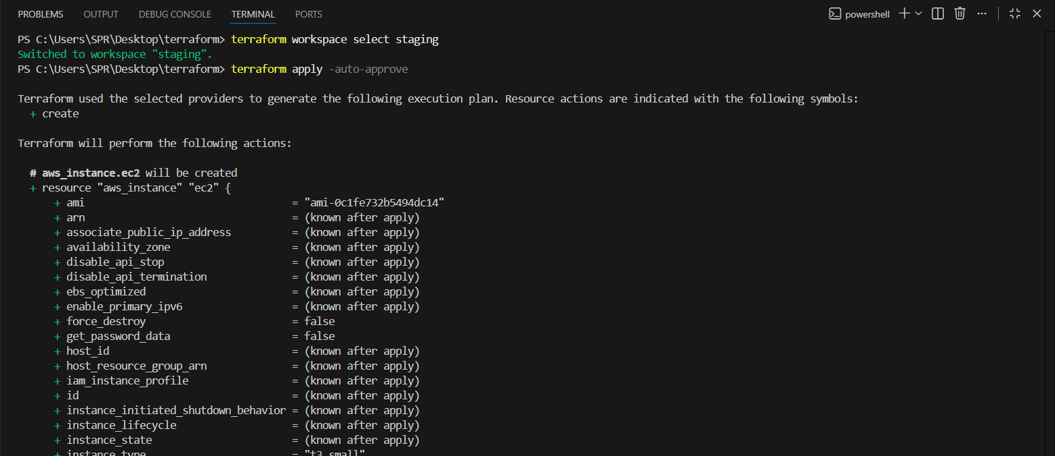
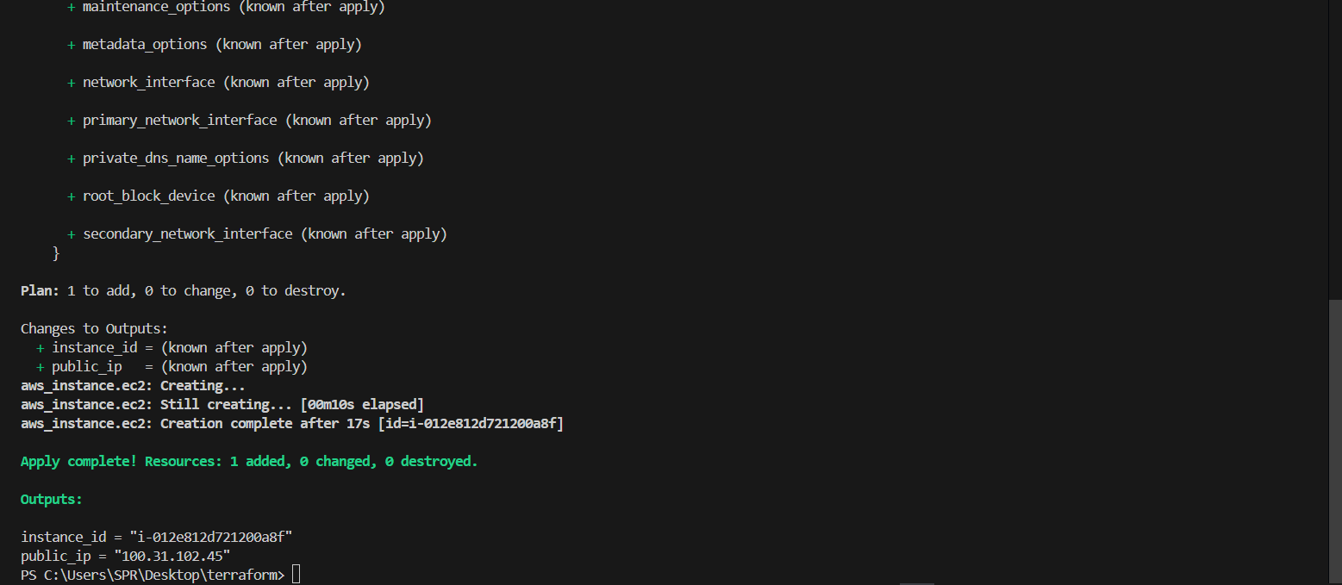

Deploy to PROD

```bash
terraform workspace select prod
terraform apply -auto-approve
```

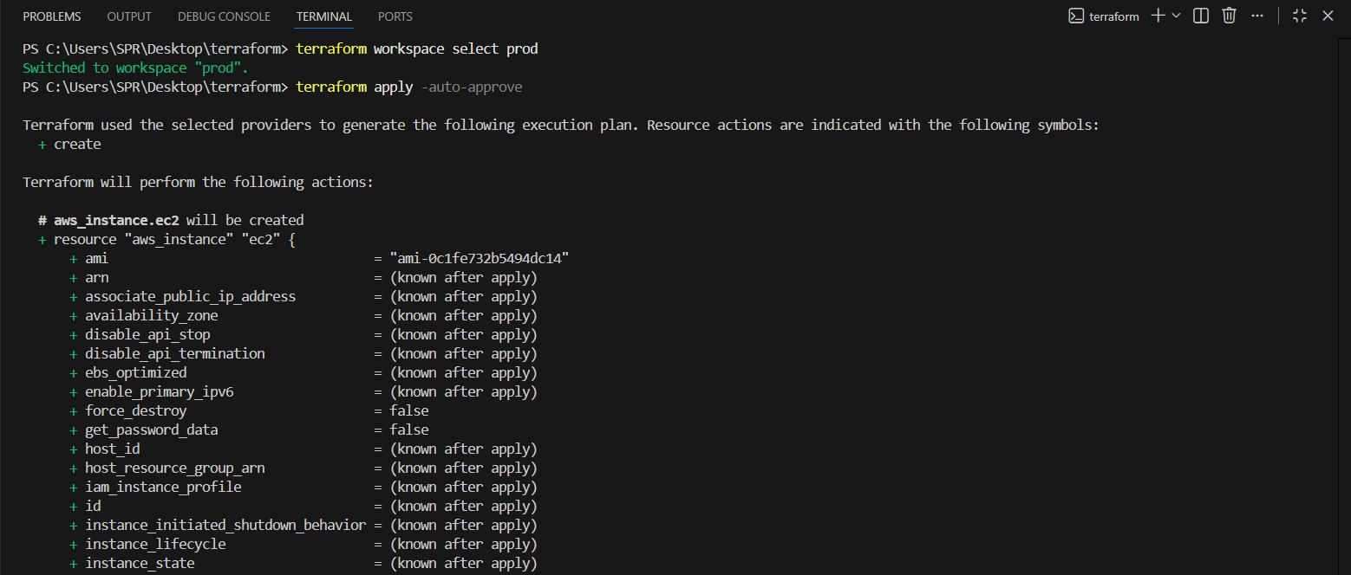
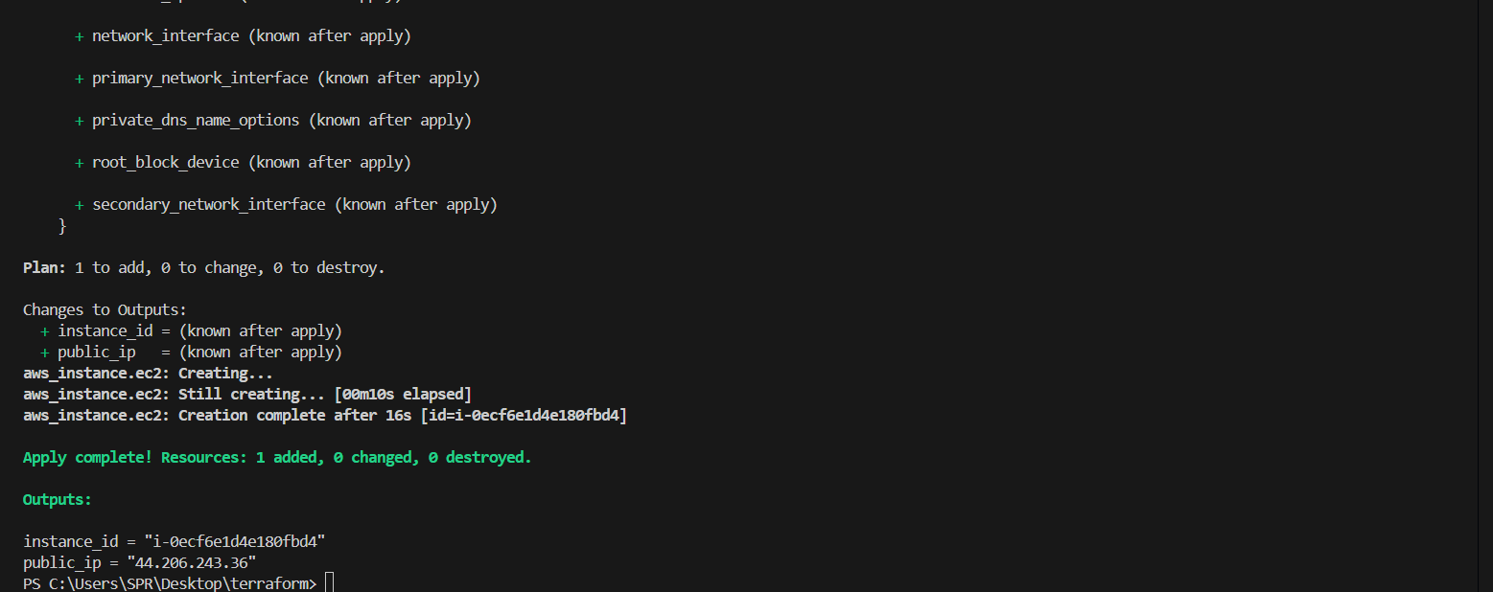

Destroy (Per Environment)

```bash
terraform workspace select dev
terraform destroy
```

*(Repeat for staging / prod)*

Result

* Separate EC2 instances per environment
* Same codebase
* Clean state separation

